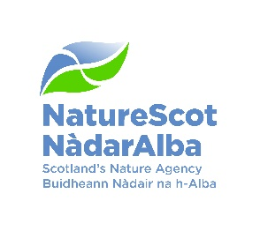
NATURE-BASED SKILLS AND CAREERS

NOTES FOR EDUCATORS AND CAREER ADVISORS

Context

Nature-based solutions provide an essential response to the climate and biodiversity crises.

At NatureScot, we’re working with many partners including Skills Development Scotland to help to realise opportunities for new jobs presented by the transition to net zero. We want to make sure there are skills pathways for young people to enter the nature-based sector, for example through developing apprenticeship models to support young people into nature-based jobs. See Nature-based jobs and skills

Key messages

- Jobs in the nature-based sector make a significant contribution to the Scottish economy amounting to 195,000 jobs or 7.5% of Scotland’s workforce in 2019. (This is likely to be an underestimate, given the difficulty in separately identifying key nature-based sectors).

- Nature-based jobs grew at more than five times the rate of all jobs in Scotland in the period 2015-19 and accounted for one third of all job growth in Scotland in this period.

- Significant further growth in nature-based jobs is anticipated on the back of expansion in activities required to meet our net zero targets. Growth in jobs in nature-based sectors such as blue carbon, woodland planting and restoration and peatland restoration between now and 2030 is expected to be significant.

Video resources for young people

- Working for Nature NatureScot’s new video series showcases young people working in the Nature-Based sector, in a range of roles and with a range of experiences to share.

- What is it like working for NatureScot? A range of NatureScot staff describe their role and their routes they took to reach their current job working for NatureScot. See the range of work areas on the NatureScot Professional advice webpage.

- Early career advice for budding environmentalists In these videos, young NatureScot staff share their experiences and tips on how to get started with a career in the environmental sector.

- The Green Jobs for Nature website provides profiles of a wide range of nature-based jobs, careers advice, where to look for vacancies and work experience opportunities and how to secure your first job Working for Nature. The website provides more examples of the jobs we need to help create a better world for nature and people.

Pathways towards nature-based jobs

- John Muir Trust nature awards infographic: Achieving awards in, through and for nature. Examples of nature-based learner journeys, pathways and progression.

- Opening Up Vocational Pathways into Nature-based Green Jobs – this report by CIEEM (the Chartered Institute of Ecology and Environmental Management) highlights the need to improve pathways into ecology jobs for young people with vocational qualifications and for mid-career changers.

- Working and Volunteering with us and Volunteer in the outdoors

- NatureScot and Youth Engagement

